SBG 3.1 Data Collection
Contents
1 AgsaSippy 2
1.1 Trace using agsaSippy 2
2 TCPdump on the SGC blade 6
2.1 How to take a TCPdump on the SGC 6
3 TCPdump on ISER blade 8
4 ASI Logs 9
4.1 ASItool 9
5 SBG Log files 11
6 ISER Log files 12
7 Abbreviations 13

AgsaSippy
AgsaSippy is a built-in module in the SGC cards which allows you to trace the traffic that goes thru the SGC cards.

Trace using agsaSippy
Here is a description of how you use agsaSippy to trace.
- First you need to log in to SIS using SSH. The default user/password is sid/sidsid
- Issue the command blades.sh to get a list of all the blades available in the system, the print-out should look like this:
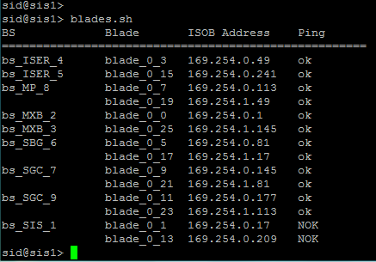
- Here you can see the Blade Systems and the blades available on your site as well as each blades ISOB Address. This is the address that you should use to connect to the blade.
To take an agsaSippy trace you should find the Call Handling (CH) blade in the corresponding SGC BS that you want to trace on. You can find this information either in the ISM GUI (Session Border Gateway > System > Blade system administration > SGC BS)
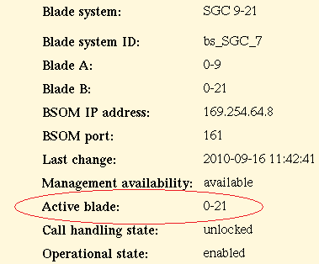
Or by issuing the Erlang command (see below on how to enter the Erlang shell) rcmI:cp_info(). in the SGC blade.
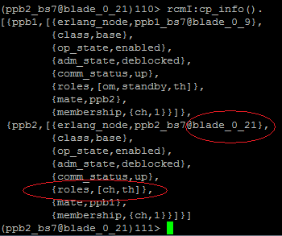
- Now we know that the CH blade for the SGC BS is blade_0_21 so we need to establish an SSH session towards that blade and from there start the agsaSippy tool. From the command blades.sh we could see the ISOB address of the blade so establish an SSH session with default user homer: ssh homer@169.254.1.81 and the default password is beammeUP.
By this stage we should be in the SGC shell:
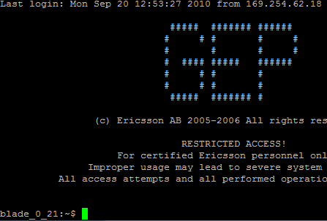
- Now we need to start the Erlang shell by typing to and Enter. The prompt should now look something like this: (ppb2_bs7@blade_0_21)111>
From here we can start using Erlang commands like to find out the CH blade (rcmI:cp_info().) etc.
Note: All Erlang commands should end with a point (.)!
- To start tracing we first need to start agsaSippy with the command agsaSippy:start(). You should get a confirmation like {ok,<0.20001.34>}
When agsaSippy is started we can now start the tracing.
- You can choose on what you want to trace i.e. sip, gcp, etc or you can choose the option all to trace everything. To start the tracing type:
agsaSippy:trace(all). You should get an ok confirmation.
- Now the tracing is on and you should be able to capture all the traffic going thru the SGC blade. To make it easier to follow the traffic flow I usually start the agsaSippy trace before making a call scenario and, if using putty, log all session output to a file.
Note: Remember that agsaSippy makes a lot of CPU load on the SGC, so use it with caution and never on a live SBG node!
- To stop the tracing and agsaSippy issue these commands:
agsaSippy:trace_stop(all). You should get an ok confirmation.
agsaSippy:stop(). You should get the following confirmation:
** exception exit: {normal,{gen_server,call,[agsaSippy,stop]}}
in function gen_server:call/2
To exit from the Erlang shell use Ctrl-d.

TCPdump on the SGC blade
To make a TCPdump is a good way to analyze the signaling traffic flow coming in and out from the SBG. The TCPdump is made on the CH SGC blade.

How to take a TCPdump on the SGC
- Follow the steps 1-3 in the agsaSippy section to find out which is the CH SGC blade and log in to that blade.
- The TCPdump application can only be run by super-user so you need to switch to super-user by entering:
su root
The default password is ncc1701D.
- In the earlier releases of SBG we could easily find the correct interface that we wanted to capture on just by typing ifconfig –a. In SBG 3.1 however there is the introduction of virtual routers in SGC which makes it a little trickier to find the right interface to capture on.
I will try to explain it here and use our SBG as example to make it more clearly on how to find the right interface.
SBG-> Session Configuration -> Open Network
We have defined 2 networks on our SBG which can be seen here:
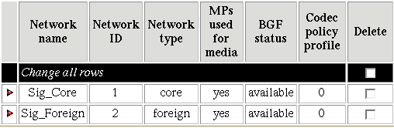
Sig_Core with network ID 1 and Sig_Foreign with network ID 2.
For Sig_Core we are using IS VLAN 257 and for Sig_Foreign we are using IS VLAN 250.
So if you for example would like to capture the signaling traffic from SBG to the Core network you should type the following command in the SGC shell: vrctl -c 1 ifconfig –a and will get the following output:
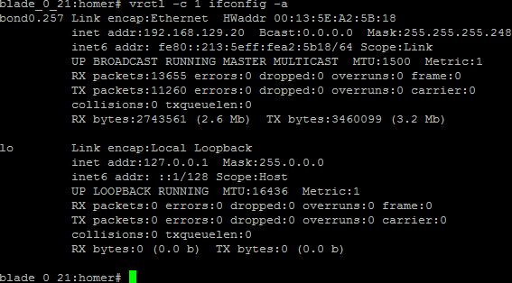
From the output we can see that the corresponding interface is bond0.257. If we wanted to have the interface to capture on the Foreign side we should use the command vrctl -c 2 ifconfig –a. The pattern is that you use vrctl –c x ifconfig –a where x is the Network ID that you can find in the ISM GUI for the particular network that you want to capture on.
- Now we want to capture on the “Core side” of the SBG so we type the
- cd /home/homer
- command: vrctl -c 1 tcpdump -i bond0.257 -s 0 -w core_side.pcap
- When the tracing are finished stop tcpdump with ctrl-c.
- You can access the capture file core_side.pcap from SIS in the directory /private/blade_0_x/homedir where x is the CH SGC blade. Just copy the pcap file to your PC and open with wireshark.
If you want to use for example SCP from SIS to copy over the files you need to be root user. Default root password for SIS is tre,14

TCPdump on ISER blade
If you ever need to trace the traffic on the ISER blade, there is also the possibility to do a TCPdump on any of the ISER interfaces.
- From the SIS type the command blades.sh to get a list of all available blades that you have in your site.
- Open a SSH connection to the ISER blade with debug user.
Default user/pass for debug user is: debug/tre,14
ssh debug@169.254.0.49
- You should now get the ISER prompt which should look like this:
boot_blade_0_3#
From here, since you are logged in as debug user you can type the command deb ! to enter to the debug shell. The prompt should now look like this: sh-2.05b#
- Now you can list all the interfaces (physical and logical) with ifconfig –a
- Now you can make a TCPdump on a specific interface by entering the command: tcpdump –i <interface> -s0 –w <name_of_file>.pcap
- When the tracing is finished stop the TCPdump process with Ctrl-c.
- The capture file is now stored on the SIS under the default directory
/private/bs_ISER_x/usr/local/home/debug/, where x is the number of the ISER BS.
- Upload the file to your PC and open with wireshark.

ASI Logs
From the ISM GUI Integrated Site Services > Logs > Transfer additional system information (for IS) and Session Border Gateway > Logs > Transfer additional system information (for SBG) you can transfer the ASI logs to an external machine. The problem is that you won’t be able to read them since they are encrypted. With the following program however you can decrypt the file and get readable ASI log files.
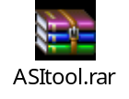
Here is a description on how to use the tool.

ASItool
- Extract the directory in ASItool.rar and place it somewhere in your PC.
In this example I have placed it C:\Users\echahad\Documents\ASItool.
- Set the application directory in the PATH variable
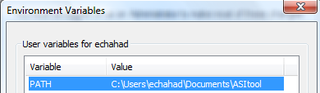
- Now in this example the ASIlog file that I want to decrypt is Charbel_asi.20100921T1230320200.tar.gz.c. So place this file in the same directory as the ASItool application, i.e. C:\Users\echahad\Documents\ASItool.
- Start a DOS terminal window.
- Change to the directory where ASItool application is located.
- Copy the ASIlogs date to a text file and insert AIK at the beginning of the string, i.e. AIK20100921T1230320200.
- Copy the whole string from the text file.
- Start the program asi.exe from DOS terminal window.
- A new DOS terminal window will pop up, paste the copied string in the new window and press enter.
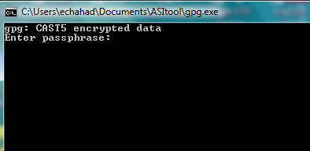
- If everything went fine you will get this confirmation for about a second and then it will disappear.
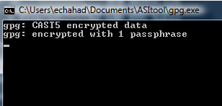
The decrypted ASI log file will be created in the same directory as you have the encrypted one, i.e. in our example now C:\Users\echahad\Documents\ASItool.

SBG Log files
In the ISM GUI under Session Border Gateway > Logs > View blade system logs you can see and open the following logs:
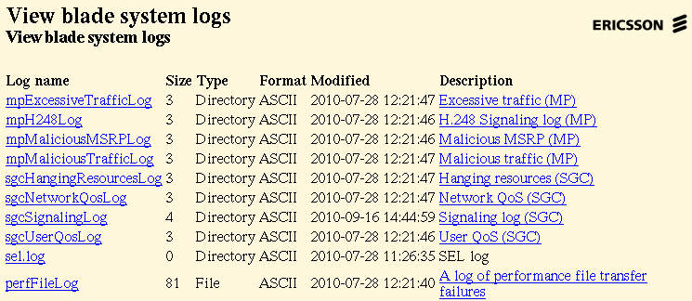

If you need to do some troubleshooting it is good to investigate these logs. There are descriptions to the logs in the description links. For example if you have problem with media it can be good to have a look in the mpMaliciousTrafficLog to see if the MP discards any RTP packets or the sgcSignalinLog for SGC signaling.
If you transfer the SBG ASI log then these logs will be added to the archive. You can also choose which of these logs you want to transfer to an external machine, in ISM GUI Session Border Gateway > Logs > Transfer blade system logs.

ISER Log files
Depending on what you are troubleshooting some ISER log files can be very helpful in order to understand and solve your problems. The ISER logs can be found in SIS in directory /private/bs_ISER_x/log, where x is the ISER BS number.
Here I list some of the logs that can be interesting to look at.
- iked_log.ssh
If you are using IPSec tunnel in the ISER and key exchange this log can be good to look at if you are experiencing problems.
- ospf.2.0.log
OSPF log.
- snmp_trans.log
SNMP traps sent from the ISER.
To be able to access the security logs of the ISER you need to be super user in the SIS. Type su and give the default password tre,14.
Now you should be able to access the .seclog/ directory (/private/bs_ISER_x/log/.seclog).
Here you can find the following logs:
- ipsec_security.log
If using IPSec on ISER here you will be able to find connection information and if you are having problem you should take a look into this log file.
- pf_security.log
This is the packet filter security log. If you apply a packet filter on any of your ISER interfaces you can have a look into this log file to see if the ISER discards any traffic etc.
- session.log
This is the session log where you can see which session have been established towards the ISER.

Abbreviations
ASI Additional System Information
BS Blade System
GUI Graphical User Interface
IKE Internet Key Exchange
IPSec IP Security
ISER Integrated Site Edge Router
ISM Integrated Site Management System
ISOB IS OaM Basic logical network
MP Media Proxy
OSPF Open Shortest Path First
RTP Real-time Transport Protocol
SBG Session Border Gateway
SCP Secure Copy
SGC Session Gateway Controller
SIS Site Infrastructure Support
SNMP Simple Network Management Protocol
SSH Secure Shell

